AUDIO COMMISSIONS FOR THE BBC
A GUIDE TO UNDERLYING CLEARANCES – January 2026

CONTENTS
- Overview of clearance requirements in the commissioning agreement between the BBC and the Producer (page 1)
- Introduction to BBC Framework Agreements with Equity, WGGB, MU (pages 1 – 2)
- Samples of different upfront clearance requirements under the BBC Frameworks i.e. initial and subsequent use payments (public service re-use and commercial exploitation) and rights acquired in the initial payments (pages 3 – 14)

----------------------------------------------------------
- Overview of clearance requirements
- The BBC’s requirements are set out in General Term 6.2 of the BBC’s General Terms of the commissioning agreement: https://downloads.bbc.co.uk/radio/commissioning/radio-general-terms-2015.pdf
- In relation to artists, writers and musicians, the Producer needs to pay for the minimum pre-paid uses which are set out in the Special Terms of the contract for that project.
- The BBC expects the Producer to use the rates and terms provided for BBC programmes in the BBC’s Framework Agreements with Equity, WGGB, and the MU.

- Introduction to BBC Framework agreements
- This guide explains how to contract actors, writers, and musicians for BBC commissioned audio speech content. Commissions covered include Commissions_Radio_4, Commissions_Podcasts , Commissions_National_Regions
- As above, the Special Terms of the commissioning agreement will state the rights you should acquire from your budget. The wording in the Special Terms mirrors the wording in the relevant framework, so that it is very clear what the Producer needs to do.

For example:- Special Terms will contains these elements
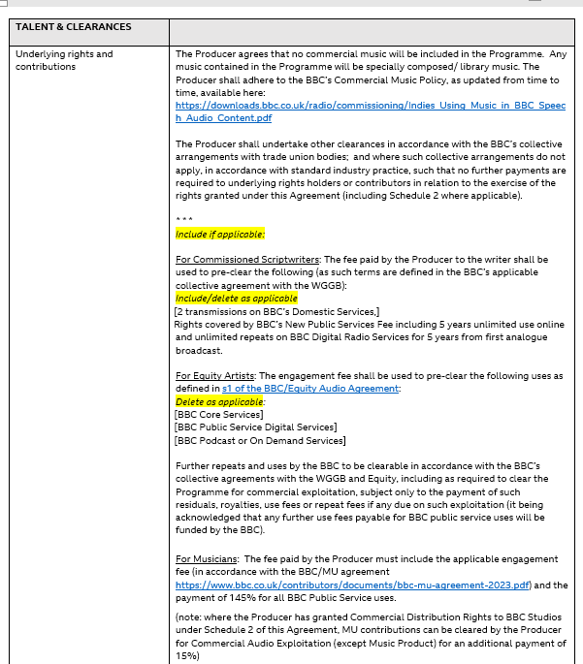

Contract according to BBC frameworks for Writers, Equity, Musicians. Otherwise buy out all uses.

Rights to acquire from production budget

Further BBC Public Service uses for actors and writers, beyond those set out in the Special Terms (e.g. repeats on R4), are paid for at the BBC’s cost in accordance with our Framework terms. These payments are often processed by the Producer (as they have the talent relationship) but reimbursed by the BBC.
Payments for commercial uses of the programmes are set out the in the Frameworks. The responsibility for making these payments lies with the Producer including when distributed by BBC Studios (unless otherwise agreed).

3. Samples of different upfront clearance requirements under the BBC Frameworks
NB Except where stated otherwise all the percentage rates are residuals i.e. a percentage of the contributor’s initial fee.
- Commissions by Radio 4
Commissioning agreement Special Terms will say this:
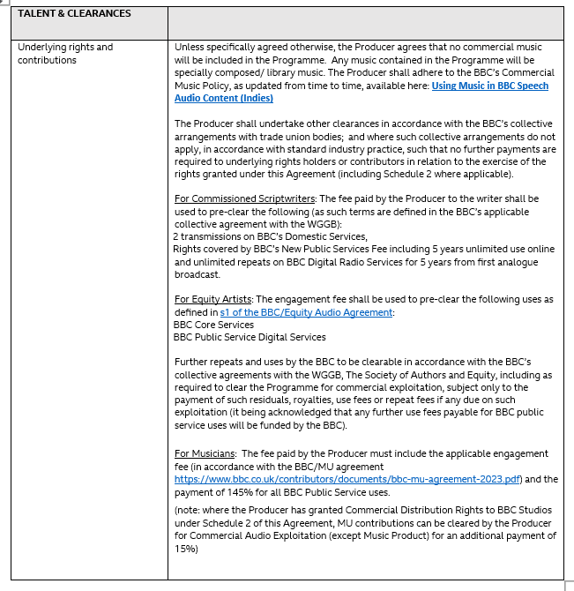
How to contract & pay writers for a Radio 4 commission
Type of Commission | Initial Upfront Payments by Producer | Payments for Public Service re-use (as required) | Payments for commercial uses (as required)
Scripts for all plays, original series, adaptations and dramatizations for Domestic services | - Pay Two Transmissions Fee (TTF) which is payable 60% on signature and 40% on Acceptance.  - On Acceptance also pay ‘New Public Service Fee’ = 15% of Single Transmission Fee (STF = 60% of Two Transmission Fee). | - 3rd + Domestic tx = 45% of TTF  - Regional tx = 30% of TTF  - WS repeat = 30% of TTF (in foreign lang = 15% of TTF for 2 txs)  - 4Extra repeat after 5 yrs = 5% of STF for 3 yrs  - Other PS uses (excluding 4Extra) after 5 years = 10% of STF for 5 yrs | - Radio Distribution World = royalty of 5.6% gross receipts(unless work is a ‘source to script transfer’ then = 4% GR)  - Non theatric (inc trapped audiences) = 2% of STF  - TV transfer & Print and Publications – To Be Agreed  - Audio Publication – see Schedule 3 & 4 of Radio Drama Agreement for details.
Link to BBC/WGGB/PMA/SOA framework : bbc-agreements-radio-rda-radio-drama-agreement-2022.pdf (Current rate card, effective December 2025).

Scripts for dramatised features | - Pay Single TX Fee (which is payable 60% on signature and 40% on Acceptance) however producer can opt to pay Two Transmission Fee.  - On Acceptance also pay ‘New Public Service Fee’ = 15% of Single Transmission Fee (STF = 60% of Two Transmission Fee). | - 2nd + Domestic tx = if Narrative 50% of STF otherwise 75% of STF  - Regional tx = if Narrative 50% of STF otherwise 75% of STF  - WS repeat = 50% of STF (in foreign lang = 25% of STF for 2 txs)  - 4Extra repeat after 5 yrs = 5% of STF for 3 yrs  - Other PS uses (excluding 4Extra) after 5 years = 10% of STF for 5 yrs | See ‘Scripts for all plays, original series, adaptations & dramatisations for Domestic Services’.
Link to BBC/WGGB/PMA/SOA framework: bbc-agreements-radio-rda-radio-drama-agreement-2022.pdf (Current rate card, effective December 2025).

How to contract Published works for Radio 4 commission
Type of Commission | Initial Upfront Payments by Producer | Payments for Public Service re-use (as required) | Payments for commercial uses (as required)
Radio 4 – complete work | - Pay Fee which is payable on First Broadcast for one broadcast.  - Also pay ‘New Public Service Fee’ = 10% of Initial Fee  Please note: For current fee level agreed between BBC and Society of Authors see Schedule One of agreement.  Translations of plays, prose and poetry are payable at two thirds of the rates - payable to each translator and original author. | - Repeat on core service or local radio – 100% of the current rate for published works on the service carrying the repeat.  - One repeat may be pre-purchased at time of first tx a cost of 80% of Initial Fee.  - Other PS uses after 5 years pay a further 10% of the Fee. | - Radio Distribution World = royalty of 1.5% gross receipts unless a straight reading and then it is 5% gross receipts.  - Non theatric (inc trapped audiences) = no further fee due see clause 2.2.1  - Audio Publication – no rights acquired.
Link to BBC /SOA framework : agreements-society-of-authors-pa5c-2014.pdf

How to contract & pay actors for a Radio 4 commission
Type of Commission | Initial Upfront Payments by Producer | Payments for Public Service re-use (as required) | Payments for commercial uses (as required)
Radio 4 | - Pay relevant Engagement Fee to buy 2 txs See below for rights acquired in Engagement Fee. | - Core’ Services (R1, R2, R3, R4, R5): 3rd and subsequent TXS within 3 years of the first TX - 33% each TX. Higher rates apply for TXs which take place after 3 years (see Agreement for details)  - BBC World Service: 23% per TX cycle (TX cycle meaning unlimited TXs within an 8 days period). Higher rates apply for TXs which take place after 3 years (see Agreement for details)  - BBC Nations (e.g. Scotland, Wales, Northern Ireland): 4 TXS in any one nation – 7%. Higher rates apply for TXs which take place after 3 years (see Agreement for details)  - Radio 4Extra – archive TXs and on-demand/podcast: collective licence negotiated and paid for by the BBC  - BBC Sounds – archive on-demand/podcast: collective licence negotiated and paid for by the BBC | - Commercial Audio Publication (e.g. Penguin Random House Deal for DTO/CD). See paragraph 603 which confirms:  - definition of receipts  - royalty payments (which vary according to genre, territory & number of voices)  - Sales to other radio stations: See paragraph 602. Either:  - residual 80% (applicable to 2 TX fees)- radio rights throughout the world; or  - 17% royalty x gross income  - Other forms of commercial exploitation: 17% royalty x gross income
Link to BBC Equity Audio Agreement : bbc-equity-audio-agreement-2024-25.pdf

How to contract & pay musicians for a Radio 4 commission

Type of Commission | Initial Upfront Payments by Producer | Payments for Public Service re-use (as required) | Payments for commercial uses (as required)
Radio 4 | - Applicable engagement fee  - Plus additional payment of 145% to acquire all rights throughout the world excluding commercial audio exploitation | None | Commercial Audio Exploitation (except Music Product) for an additional payment of 15%  (Producer to pay this fee if they have granted Commercial Distribution to BBC Studios)
Link to BBC/MU agreement bbc-mu-agreement-2023.pdf

Clearance notes for a Radio 4 commission – rights acquired in initial upfront fees
Rights acquired by upfront Writers Fees paid by the Producer. | Rights acquired by the Script Fee  - exclusive irrevocable licence of copyright in the Script to use and exploit the Script throughout the world by all means in perpetuity subject to certain rights which are reserved to the writer (see below).  - Fee also includes incorporation of extracts from a performance of the Script in further programmes along with the reuse and exploitation of the new programme. Extracts must be a) limited to 25% of the Script or 10 minutes in duration whichever is the lesser b) extracts must not infringe the Writers right of integrity under section 80 of the Copyright Act c) consent is only required where i) the programme using the extract has a presenters whose role is as a celebrity and not an interviewer or ii) the extract itself is a defining moment in the original programme.  - Rights reserved to the writer: Changed Format (in certain circumstances), Television Transfer, Stage and Theatric – see relevant clauses in RDA for detail.  Rights acquired by the New Public Service Fee  - All uses of the Script on any Public Service but excluding repeats on the Domestic Services and World Service for 5 years from being made available.  - Podcasts of radio programmes available in the Public Service for a period of 5 years from being made available.  Definitions: For Definitions of Public Service, Domestic Services, Designated Channels, Changed Format, Audio Publication etc please see RDA.
Rights acquired by upfront Fee for Published Works paid by the Producer (complete works only) | Rights acquired by the Initial Fee  - Non-exclusive right to reproduce the Work (including the right to abridge, adapt and translate for the purpose of broadcast) for the duration of copyright and to repeat and exploit the programme containing the work subject to payment of residuals and royalties. Certain commercial uses are not permitted under the agreement e.g. commercial audio publication.  Please note: the standard contract asks for world rights however not all publishers own world rights and so the contract is amended accordingly.  - Public Service Podcasts for up to 30 days from transmissions (Podcasts are not permitted prior to first transmission)  Rights acquired by the New Public Service Fee  - Further broadcasts on BBC Public Service Channels and use of any Public Service excluding Core Services (Radio 1-5, Five Live, BBC Nation Regions and World Service) for 5 years from first broadcast.  Please note: the standard contract states 5 years for public service rights however this is on occasion amended to 30 days from the last episode.
Rights acquired by Actor’s Engagement Fee paid by the Producer | - 2 TXs  - Simultaneous transmission throughout the world  - Promotional and publicity use (inc the right to record a trailer, if the recording takes place whilst the artist is under contract.  - PS podcasts/streaming for 5 years from the date the programme is made available  - EBU: full members – broadcast programme within 1 year of first broadcast; or associate members broadcast programme within 30 days of first broadcast  - World non-theatric rights (exhibition to a non-paying or trapped audience)  - Podcasts and streams (live or on-demand) – commercialised throughout the world (excluding the UK)
Rights acquired by the musicians Engagement Fee paid by the Producer | Rights Acquired by the Engagement Fee plus 145% additional payment  All rights throughout the world (including publicity and promotion use) in perpetuity excluding Commercial Audio Exploitation

Commissions for Podcasts
Commissioning agreement Special Terms will say this:
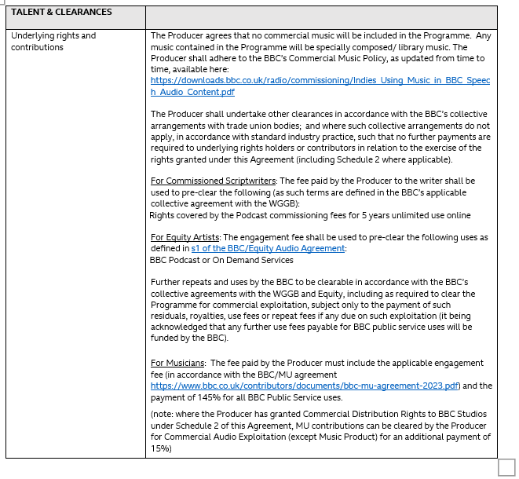

How to contract & pay writers for a Podcast commission
Type of Commission | Initial Upfront Payments by Producer | Payments for Public Service re-use (as required) | Payments for commercial uses (as required)
Scripts for Podcasts | - Podcast fee payable (see agreement for current rates) which is payable 60% on signature and 40% on Acceptance) | - Domestic tx = 75% of STF  - Regional tx = 50% of STF  - WS repeat = 50% of STF (in foreign lang = 25% of STF for 2 txs)  - 4Extra repeat after 5 yrs = 5% of STF for 3 yrs  - Other PS uses (excluding 4Extra) after 5 years = 10% of STF for 5 yrs | - Radio Distribution World = royalty of 5.6% gross receipts (unless work is a ‘source to script transfer’ then = 4% GR)  - Non theatric (inc trapped audiences) = 2% of STF  - TV transfer & Print and Publications – To Be Agreed  - Audio Publication – see Schedule 3 & 4 of Radio Drama Agreement for details.
Link to BBC/WGGB/PMA/SOA Framework : bbc-agreements-radio-rda-radio-drama-agreement-2022.pdf

How to contract & pay published works for a Podcast commission

There are no terms in the framework for a podcast origination.

How to contract & pay actors for a Podcast commission
Type of Commission | Initial Upfront Payments by Producer | Payments for Public Service re-use (as required) | Payments for commercial uses (as required)
Podcasts - Drama & Comedy  (see below for additional terms for ‘short-form’ and readings) | - Pay reduced Engagement Fee i.e. 66% of the 2 TXS Fee. (also known as the 1 TX fee).  See below for rights acquired in Engagement Fee. | - ‘Core’ Services (R1, R2, R3, R4, R5): 50% per TX. Higher rates apply for TXs which take place after 3 years (see Agreement for details)  - BBC World Service: 35% per TX cycle (TX cycle meaning unlimited TXs within an 8 days period). Higher rates apply for TXs which take place after 3 years (see Agreement for details)  - BBC Nations (e.g. Scotland, Wales, Northern Ireland): 4 TXS in any one nation – 7%. Higher rates apply for TXs which take place after 3 years (see Agreement for details)  - Radio 4Extra – archive TXs and on-demand/podcast: collective licence negotiated and paid for by the BBC  - BBC Sounds – archive on-demand/podcast: collective licence negotiated and paid for by the BBC | - Commercial Audio Publication (e.g. Penguin Random House Deal for DTO/CD). See paragraph 603 which confirms:  - definition of receipts  - royalty payments (which vary according to genre, territory & number of voices)  - Sales to other radio stations: See paragraph 602. Either:  - residual 80% (applicable to 2 TX fees)- radio rights throughout the world; or  17% royalty x gross income Other forms of commercial exploitation: 17% royalty x gross income
Podcast – Short Form & Readings | - Additional reduced rates detailed in paragraph 215. | - ‘Core’ Services (R1, R2, R3, R4, R5): 50% per TX. Higher rates apply for TXs which take place after 3 years (see Agreement for details)  - BBC World Service: 35% per TX cycle (TX cycle meaning unlimited TXs within an 8 days period). Higher rates apply for TXs which take place after 3 years (see Agreement for details)  - BBC Nations (e.g. Scotland, Wales, Northern Ireland): 4 TXS in any one nation – 7%. Higher rates apply for TXs which take place after 3 years (see Agreement for details)  - Radio 4Extra – archive TXs and on-demand/podcast: collective licence negotiated and paid for by the BBC  - BBC Sounds – archive on-demand/podcast: collective licence negotiated and paid for by the BBC | - Commercial Audio Publication (e.g. Penguin Random House Deal for DTO/CD). See paragraph 603 which confirms:  - definition of receipts  - royalty payments (which vary according to genre, territory & number of voices)  - Sales to other radio stations: See paragraph 602. Either:  - residual 80% (applicable to 2 TX fees)- radio rights throughout the world; or  - 17% royalty x gross income Other forms of commercial exploitation: 17% royalty x gross income
Link to BBC Equity Audio Agreement : bbc-equity-audio-agreement-2024-25.pdf

How to contract & pay musicians for a Podcast commission: -

Type of Commission | Initial Upfront Payments by Producer | Payments for Public Service re-use (as required) | Payments for commercial uses (as required)
Podcasts | - Applicable engagement fee  - Plus additional payment of 145% to acquire all rights throughout the world excluding commercial audio exploitation | None | Commercial Audio Exploitation (except Music Product) for an additional payment of 15%  (Producer to pay this fee if they have granted Commercial Distribution to BBC Studios)
Link to BBC/MU agreement bbc-mu-agreement-2023.pdf

Clearance notes for a Podcast:
Rights acquired by upfront Writers Fees paid by the Producer. | Rights acquired by the Script Fee  - PS Podcasts rights for 5 years  - exclusive irrevocable licence of copyright in the Script to use and exploit the Script throughout the world by all means in perpetuity subject to certain rights which are reserved to the writer (see below).  - Fee also include incorporation of extracts from a performance of the Script in further programmes along with the reuse and exploitation of the new programme. Extracts must be a) limited to 25% of the Script or 10 minutes in duration whichever is the lesser b) extracts must not infringe the Writers right of integrity under section 80 of the Copyright Act c) consent is only required where i) the programme using the extract has a presenters whose role is as a celebrity and not an interviewer or ii) the extract itself is a defining moment in the original programme.  - Rights reserved to the writer : Changed Format (in certain circumstances) , Television Transfer, Stage and Theatric – see relevant clauses in RDA for detail.
Rights acquired by Actor’s Engagement Fee paid by the Producer | - PS podcasts / streaming for 5 years  - Promotional and publicity use (inc the right to record a trailer, if the recording takes place whilst the artist is under contract.  - EBU: full members – broadcast programme within 1 year of first broadcast; or associate members broadcast programme within 30 days of first broadcast  - World non-theatric rights (exhibition to a non-paying or trapped audience)  - Podcasts and streams (live or on-demand) – commercialised throughout the world (excluding the UK)
Rights acquired by the upfront musicians’ payment paid by the Producer | Rights Acquired by the Engagement Fee plus 145%: All rights throughout the world (including publicity and promotion use) in perpetuity excluding Commercial Audio Exploitation

- Commissions for National Regions
Commissioning agreement Special Terms will usually say this:

How to contract & pay writers for a National Regions commission

Type of Commission | Initial Upfront Payments by Producer | Payments for Public Service re-use (as required) | Payments for commercial uses (as required)
Scripts for National Regions | - Pay Single TX Fee (which is payable 60% on signature and 40% on Acceptance) or you might be asked to pay the Two Transmission Fee (see Special Terms to confirm).  - On Acceptance also pay ‘New Public Service Fee’ = 15% of Single Transmission Fee (STF = 60% of Two Transmission Fee). | - 2nd + Domestic tx = if Narrative 50% of STF otherwise 75% of STF  - Regional tx = if Narrative 50% of STF otherwise 75% of STF  - WS repeat = 50% of STF (in foreign lang = 25% of STF for 2 txs)  - 4Extra repeat after 5 yrs = 5% of STF for 3 yrs  - Other PS uses (excluding 4Extra) after 5 years = 10% of STF for 5 yrs | - Radio Distribution World = 5.6% gross receipts (unless work is a ‘source to script transfer’ then = 4% GR)  - Non theatric (inc trapped audiences) = 2% of STF  - TV transfer & Print and Publications – To Be Agreed  - Audio Publication – see Schedule 3 & 4 of Radio Drama Agreement for details.
Link to BBC/WGGB/PMA/SOA Framework : bbc-agreements-radio-rda-radio-drama-agreement-2022.pdf

How to contract & pay Published works for a National Regions commissions

Type of Commission | Initial Upfront Payments by Producer | Payments for Public Service re-use (as required) | Payments for commercial uses (as required)
National Region – complete work | - Pay Fee which is payable on First Broadcast for one broadcast.  - Also pay ‘New Public Service Fee’ = 10% of Initial Fee  Please note: For current fee level agreed between BBC and Society of Authors see Schedule One of agreement.  Translations of plays, prose and poetry are payable at two thirds of the rates payable to each translator and original author. | - Repeat on core service or local radio – 100% of the current rate for published works on the service carrying the repeat.  - One repeat may be pre-purchased at time of first tx a cost of 80% of Initial Fee.  - Other PS uses after 5 years pay a further 10% of the Fee. | - Radio Distribution World = royalty of 1.5% gross receipts unless a straight reading and then it is 5% gross receipts.  - Non theatric (inc trapped audiences) = no further fee due see clause 2.2.1  - Audio Publication – no rights acquired.
Link to BBC SOA framework: agreements-society-of-authors-pa5c-2014.pdf

How to contract & pay actors for a National Regions commission
Type of Commission | Initial Upfront Payments by Producer | Payments for Public Service re-use (as required) | Payments for commercial uses (as required)
National Region | - Pay reduced Engagement Fee i.e. 66% of the 2 TXS Fee (also known as the 1 TX fee). If more TXS are required see opposite column (pay 7% for further 4 TXS in any one Nation)  See below for rights acquired in Engagement Fee. | - ‘Core’ Services (R1, R2, R3, R4, R5): 50% per TX. Higher rates apply for TXs which take place after 3 years (see Agreement for details)  - BBC World Service: 35% per TX cycle (TX cycle meaning unlimited TXs within an 8 days period). Higher rates apply for TXs which take place after 3 years (see Agreement for details)  - BBC Nations (e.g. Scotland, Wales, Northern Ireland): 4 TXS in any one nation – 7%. Higher rates apply for TXs which take place after 3 years (see Agreement for details)  - Radio 4Extra – archive TXs and on-demand/podcast: collective licence negotiated and paid for by the BBC  - BBC Sounds – archive on-demand/podcast: collective licence negotiated and paid for by the BBC | - Commercial Audio Publication (e.g. Penguin Random House Deal for DTO/CD). See paragraph 603 which confirms:  - definition of receipts  - royalty payments (which vary according to genre, territory & number of voices)  - Sales to other radio stations: See paragraph 602. Either:  - residual 80% - radio rights throughout the world; or  - 17% royalty x gross income Other forms of commercial exploitation: 17% royalty x gross income
Link to BBC Equity Audio Agreement : bbc-equity-audio-agreement-2024-25.pdf

How to contract & pay musicians for a National Regions commission

Type of Commission | Initial Upfront Payments by Producer | Payments for Public Service re-use (as required) | Payments for commercial uses (as required)
National Region | - Applicable engagement fee  - Plus additional payment of 145% to acquire all rights throughout the world excluding Commercial Audio Exploitation | None | Commercial Audio Exploitation (except Music Product) for an additional payment of 15%  (Producer to pay this fee if they have granted Commercial Distribution to BBC Studios)
Link to BBC/MU agreement bbc-mu-agreement-2023.pdf

Clearance notes for a National Regions commission
Rights acquired by upfront Writers Fees paid by the Producer. | Rights acquired by the Script Fee  - exclusive irrevocable licence of copyright in the Script to use and exploit the Script throughout the world by all means in perpetuity subject to certain rights which are reserved to the writer (see below).  - Fee also includes incorporation of extracts from a performance of the Script in further programmes along with the reuse and exploitation of the new programme. Extracts must be a) limited to 25% of the Script or 10 minutes in duration whichever is the lesser b) extracts must not infringe the Writers right of integrity under section 80 of the Copyright Act c) consent is only required where i) the programme using the extract has a presenters whose role is as a celebrity and not an interviewer or ii) the extract itself is a defining moment in the original programme.  - Rights reserved to the writer: Changed Format (in certain circumstances), Television Transfer, Stage and Theatric – see relevant clauses in RDA for detail.  Rights acquired by the New Public Service Fee  - All uses of the Script on any Public Service but excluding repeats on the Domestic Services and World Service for 5 years from being made available.  - Podcasts of radio programmes available in the Public Service for a period of 5 years from being made available.  Definitions: For Definitions of Public Service, Domestic Services, Designated Channels, Changed Format, Audio Publication etc please see RDA.
Rights acquired by upfront Fee for Published Works paid by the Producer (complete works only) | Rights acquired by the Initial Fee  - Non-exclusive right to reproduce the Work (including the right to abridge, adapt and translate for the purpose of broadcast) for the duration of copyright and to repeat and exploit the programme containing the work subject to payment of residuals and royalties. Certain commercial uses are not permitted under the agreement e.g. commercial audio publication.  Please note: the standard contract asks for world rights however not all publishers own world rights and so the contract is amended accordingly.  - Public Service Podcasts for up to 30 days from transmissions (Podcasts are not permitted prior to first transmission)  Rights acquired by the New Public Service Fee  - Further broadcasts on BBC Public Service Channels and use of any Public Service excluding Core Services (Radio 1-5, Five Live, BBC Nation Regions and World Service) for 5 years from first broadcast.  Please note: the standard contract states 5 years for public service rights however this is on occasion amended to 30 days from the last episode.
Rights acquired by Actor’s Engagement Fee paid by the Producer | - 1 TX  - PS podcasts / streaming for 5 years  - Promotional and publicity use (inc the right to record a trailer, if the recording takes place whilst the artist is under contract.  - EBU: full members – broadcast programme within 1 year of first broadcast; or associate members broadcast programme within 30 days of first broadcast  - World non-theatric rights (exhibition to a non-paying or trapped audience)  - Podcasts and streams (live or on-demand) – commercialised throughout the world (excluding the UK)
Rights acquired by the upfront musicians’ payment paid by the Producer | Rights Acquired by the Engagement Fee plus 145% additional payment: All rights throughout the world (including publicity and promotion use) in perpetuity excluding Commercial Audio Exploitation

“Adaptation”: a fictional dramatic work for a single programme or Series which converts an existing dramatic work written for another medium (such as a stage play) into a Script or Scripts for radio or Podcast provided that such an adaptation requires substantial reworking of the original (for example in terms of invention of scenes, characters and dialogue or structural changes) and for clarity adaptations not requiring such substantial reworking do not fall under this Agreement
“Dramatisation”: a single programme of fictional drama or a Series whose Script converts into dramatic form for radio or Podcast a work not already in dramatic form such as a novel or a story
“Radio Distribution”: all forms of commercial radio distribution of a sound recording of a performance of the Script however transmitted or delivered whether now or hereafter known and including without limitation all forms of terrestrial broadcast, cable (and including any equivalent on-line, on-demand, streaming or webcast distribution) and/or satellite distribution but excluding other categories of commercial distribution set out in Schedule Three and also excluding ancillary rights set out in Clause 5 and for the avoidance of doubt any Public Service use.
References to gross income and gross receipts throughout the document mean producer’s gross income or gross receipts
“Audio Publication”: the manufacture sale licensing and distribution of a commercial product which may comprise any device contrivance or appliance (including without limitation gramophone discs, compact discs, DAT and audio tapes) and every technical means or carrier now or hereafter known which is capable of bearing or emitting sound (unaccompanied by visual images) based on or derived from or consisting of a sound recording of a performance of the Script which may be abridged edited or adapted for the purpose subject to a limit of ten percent of the programme incorporating the script and provided that edits over that limit shall be subject to the Writer’s consent (not to be unreasonably withheld). If the Writer is not reasonably available then the edit can be undertaken by the original producer of the programme. Distribution will be of a product intended solely for private use by members of the public and including the right to sell electronic copies via the internet or other on-line or any other digital means (including where permanent access to a copy is authorised whether or not it is downloaded) to members of the public but excluding Radio Distribution and such sound recording of a performance of the Script shall be referred to as an “Audio Recording
“Dramatised Feature”: radio programme whose Script contains a fictional treatment in dramatic form of a factual subject. The Script will also contain non-dramatic elements but only the minutage of the dramatic elements shall be used to calculate the qualification of the Writer for the minimum rate for writers under this Agreement set out in Schedule One
“Radio Distribution” means all forms of commercial radio distribution of a sound recording incorporating the Work however transmitted or delivered whether now or hereafter known and including without limitation all forms of subscription audio, terrestrial broadcast, cable (and including any equivalent on-line, on-demand, streaming or webcast distribution) and/or satellite distribution and including for clarity the right to relay the Programme to the British Forces Broadcasting Service (BFBS) and to sell rent or hire electronic copies via the internet or other on-line means to members of the public for transmission to a physical carrier provided that each such copy made available shall be protected by a copy control mechanism allowing access for a maximum period of thirty days. For clarity Radio Distribution shall exclude Non-theatric Distribution and any Public Service use
References to gross income and gross receipts throughout the document mean producer’s gross income or gross receipts
Applies when financially prudent (e.g. monologue/show with few actors + high producer income). However, royalty typically applies. Note 1 applies to all residual references below
Artist’s payment is due when their share of the royalty equals £25.00 or more (NB this applies to all references to the royalty below). Note 2 applies to all royalty references below
Actors: this provision covers the commercialisation of BBC Sounds, which is currently achieved through certain deals e.g. Acast. Not intended for use for audio-book deals (e.g. BBC Studios Distribution arrangement with Penguin Random House). This note applies to all references to commercialised podcasts and streams below
Radio Distribution”: all forms of commercial radio distribution of a sound recording of a performance of the Script however transmitted or delivered whether now or hereafter known and including without limitation all forms of terrestrial broadcast, cable (and including any equivalent on-line, on-demand, streaming or webcast distribution) and/or satellite distribution but excluding other categories of commercial distribution set out in Schedule Three and also excluding ancillary rights set out in Clause 5 and for the avoidance of doubt any Public Service use
Audio Publication”: the manufacture sale licensing and distribution of a commercial product which may comprise any device contrivance or appliance (including without limitation gramophone discs, compact discs, DAT and audio tapes) and every technical means or carrier now or hereafter known which is capable of bearing or emitting sound (unaccompanied by visual images) based on or derived from or consisting of a sound recording of a performance of the Script which may be abridged edited or adapted for the purpose subject to a limit of ten percent of the programme incorporating the script and provided that edits over that limit shall be subject to the Writer’s consent (not to be unreasonably withheld). If the Writer is not reasonably available then the edit can be undertaken by the original producer of the programme. Distribution will be of a product intended solely for private use by members of the public and including the right to sell electronic copies via the internet or other on-line or any other digital means (including where permanent access to a copy is authorised whether or not it is downloaded) to members of the public but excluding Radio Distribution and such sound recording of a performance of the Script shall be referred to as an “Audio Recording”
Radio Distribution”: all forms of commercial radio distribution of a sound recording of a performance of the Script however transmitted or delivered whether now or hereafter known and including without limitation all forms of terrestrial broadcast, cable (and including any equivalent on-line, on-demand, streaming or webcast distribution) and/or satellite distribution but excluding other categories of commercial distribution set out in Schedule Three and also excluding ancillary rights set out in Clause 5 and for the avoidance of doubt any Public Service use
Audio Publication”: the manufacture sale licensing and distribution of a commercial product which may comprise any device contrivance or appliance (including without limitation gramophone discs, compact discs, DAT and audio tapes) and every technical means or carrier now or hereafter known which is capable of bearing or emitting sound (unaccompanied by visual images) based on or derived from or consisting of a sound recording of a performance of the Script which may be abridged edited or adapted for the purpose subject to a limit of ten percent of the programme incorporating the script and provided that edits over that limit shall be subject to the Writer’s consent (not to be unreasonably withheld). If the Writer is not reasonably available then the edit can be undertaken by the original producer of the programme. Distribution will be of a product intended solely for private use by members of the public and including the right to sell electronic copies via the internet or other on-line or any other digital means (including where permanent access to a copy is authorised whether or not it is downloaded) to members of the public but excluding Radio Distribution and such sound recording of a performance of the Script shall be referred to as an “Audio Recording”
“Radio Distribution” means all forms of commercial radio distribution of a sound recording incorporating the Work however transmitted or delivered whether now or hereafter known and including without limitation all forms of subscription audio, terrestrial broadcast, cable (and including any equivalent on-line, on-demand, streaming or webcast distribution) and/or satellite distribution and including for clarity the right to relay the Programme to the British Forces Broadcasting Service (BFBS) and to sell rent or hire electronic copies via the internet or other on-line means to members of the public for transmission to a physical carrier provided that each such copy made available shall be protected by a copy control mechanism allowing access for a maximum period of thirty days. For clarity Radio Distribution shall exclude Non-theatric Distribution and any Public Service use

