What to expect after submitting your Proposal

Submitting your Proposal
Once you have submitted your proposal you will see the below pop up, this indicates that your proposal has been successfully submitted to the chosen genre/network for review.
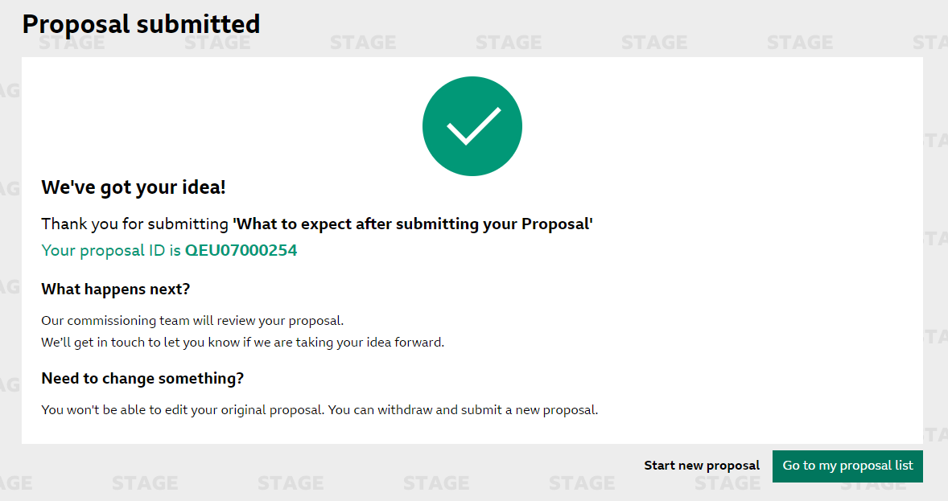

‘Proposal List’ page
You can view your proposal in the ‘proposal list’ page. Here you will be able to search and bring back any proposals, in any status, that have been submitted by either yourself or your supplier group.
You can filter on the options below to bring back specific results, for example by network and round.
Here you can also see the ‘status’ of your proposal as well as the ‘proposal no.’ and the date the proposal was ‘last updated’.
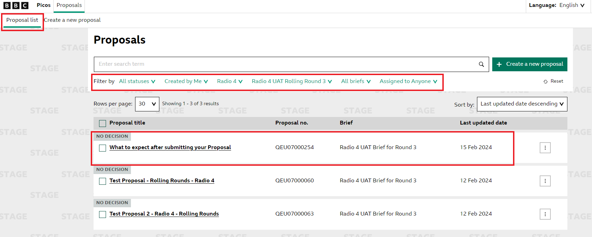

Proposal statuses and email notifications
After the proposal has been successfully submitted, it is instantly available by the commissioning teams to review.
Commissioning teams will then apply a status to your submitted proposal which could be the following:
- No decision – The commissioners have not yet reviewed or are in the process of reviewing
- More info – The commissioner has requested the supplier to provide more information
- On hold – The commissioner has placed the Proposal ‘on hold’. This can be for many reasons but for example, the idea is good but they cannot commit to a commission yet or if the idea needs further development
- Conditionally commissioned – Your proposal has been commissioned based on a set of provisions
- Rejected – The commissioners will not be proceeding with your proposal
- Shortlisted - Your proposal has been shortlisted to potentially be commissioned
- Withdrawn – The supplier has withdrawn their proposal from consideration
- Awaiting full proposal – This is for a proposal that is submitted into a ‘Two-step Round’ and the commissioner has decided to take the proposal to the next stage for a ‘full proposal’

How to check the status of your Proposal
To check the status of your proposal you will need to navigate to the proposals page. To do this, click on ‘proposals’ at the top of the page.
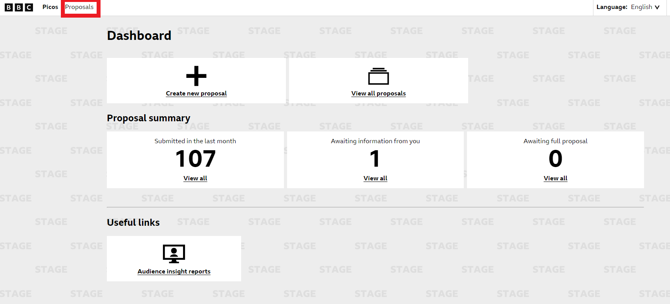
From here, you will be able see all proposals that have been ‘created by you’. You can change this to all proposals by your supplier by amending your filters.
The status of all your proposals can be seen in the top left of each proposal.
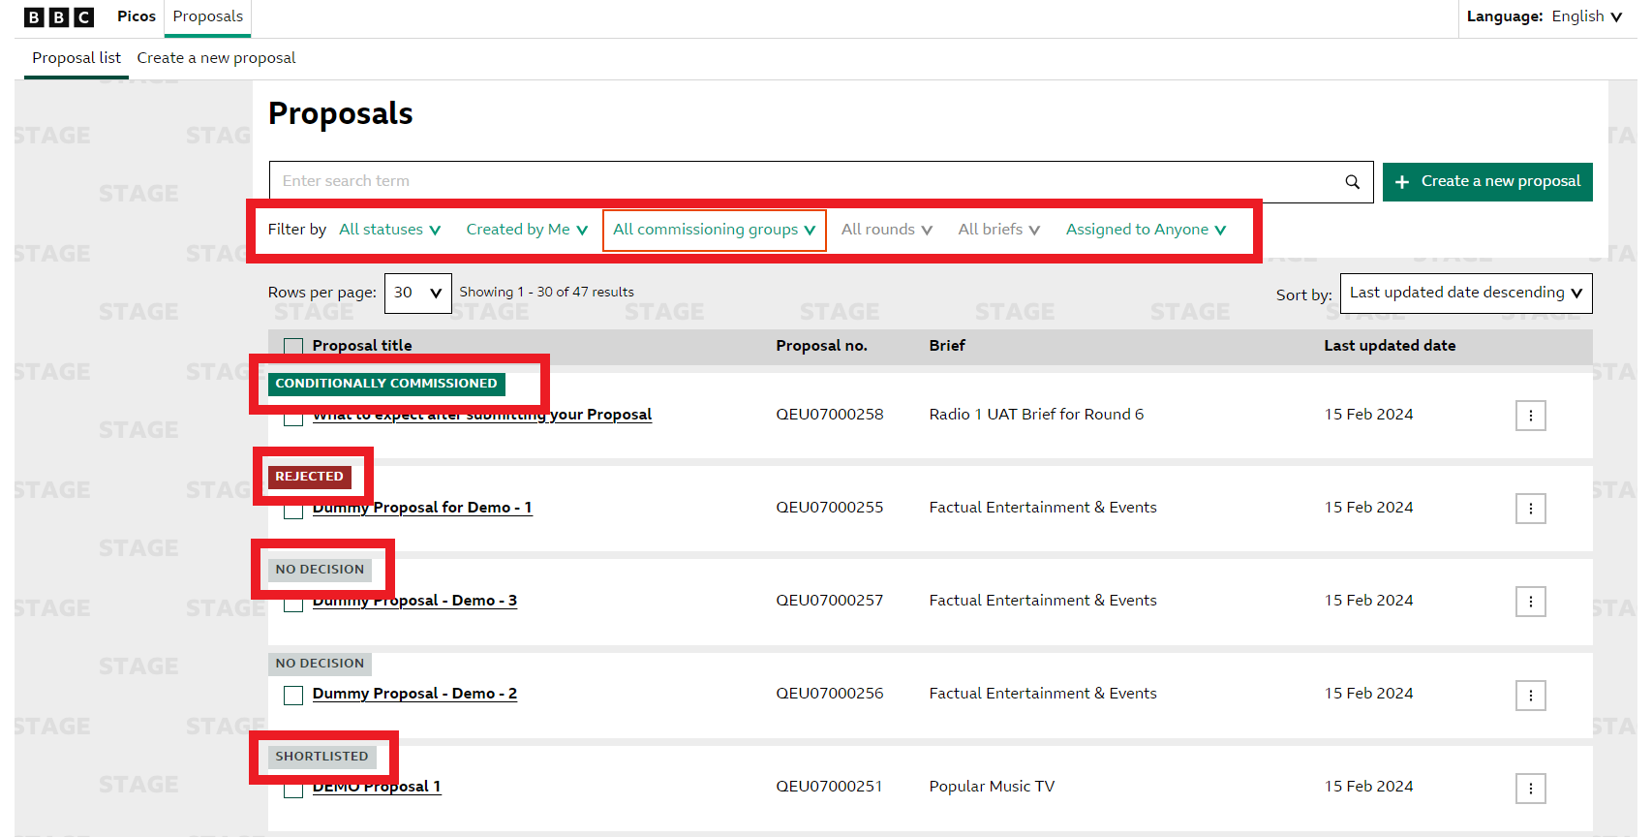

Email notifications
When your proposal is updated by the commissioner there are a range of email notifications you may receive.
You will receive email notifications for the following status updates
- On hold
- More Info
You may receive email notifications for the following status updates
- Conditionally Commissioned
- Rejected
- Shortlisted
- Awaiting Full Proposal

More information required
If your proposal has a status of ‘More Info’, you will be able to go back into your proposal in order to edit and add the required information.
If a proposal is requiring more information you can navigate to these proposals by clicking on the ‘Awaiting information from you’ box on the dashboard.
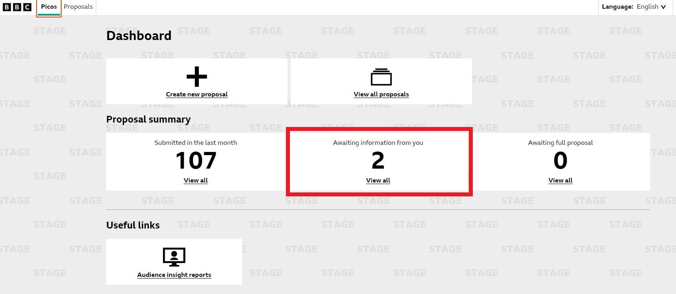
Once you have navigated to that page, you will be able to see all proposals that have a status of ‘More Info’. This will automatically filter proposals that are ‘Created by you’. To see all proposals that the supplier has submitted, amend your filters to show all results.
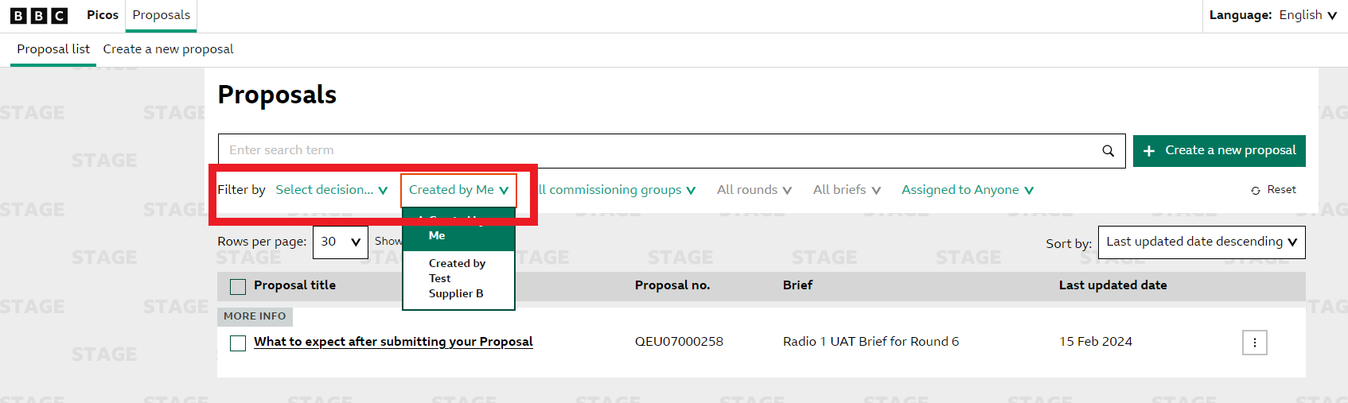
You can then select the proposal that you would like to update with more information by clicking on the title of the proposal. Once you are in the specific proposal, you will be able to view the commissioner notes in the ‘Commissioner feedback and notes’ section at the bottom of the page.
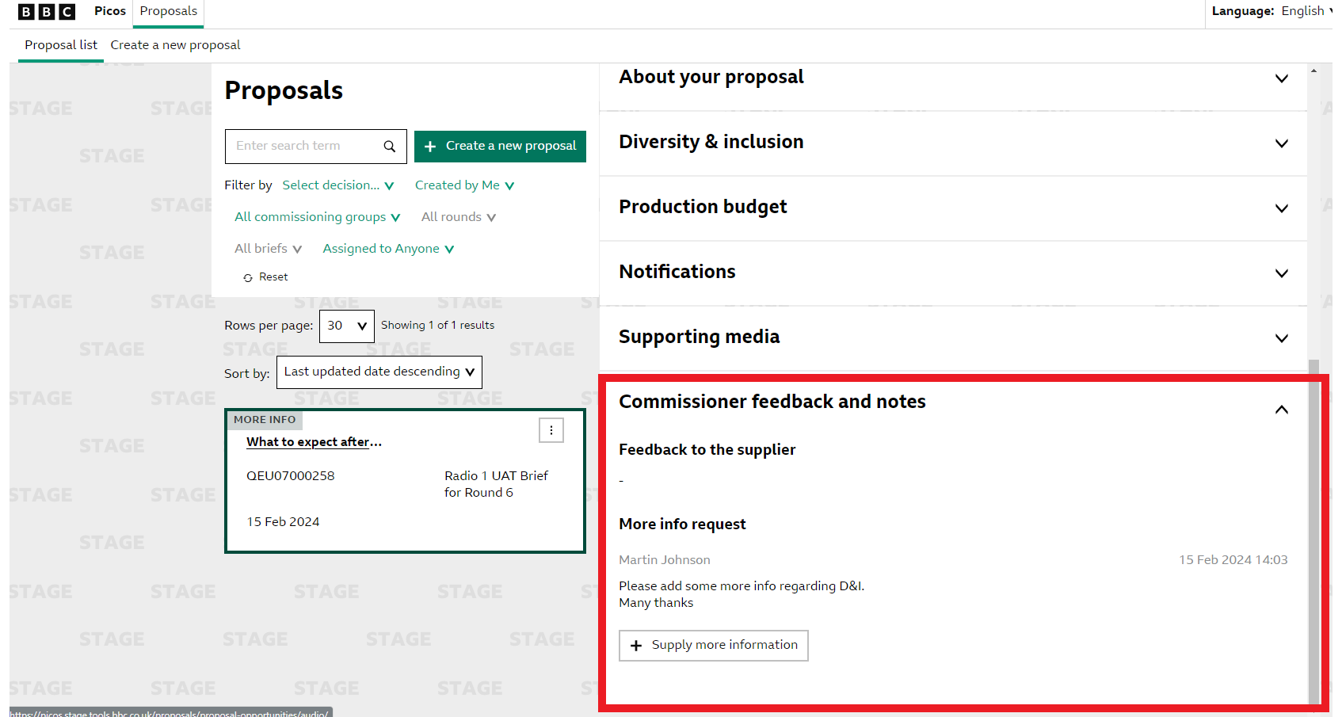
After reviewing the ‘More Info Request’ you can then supply more information by clicking on the ‘Supply more Information’ button in the ‘Commissioner feedback and notes’ section.
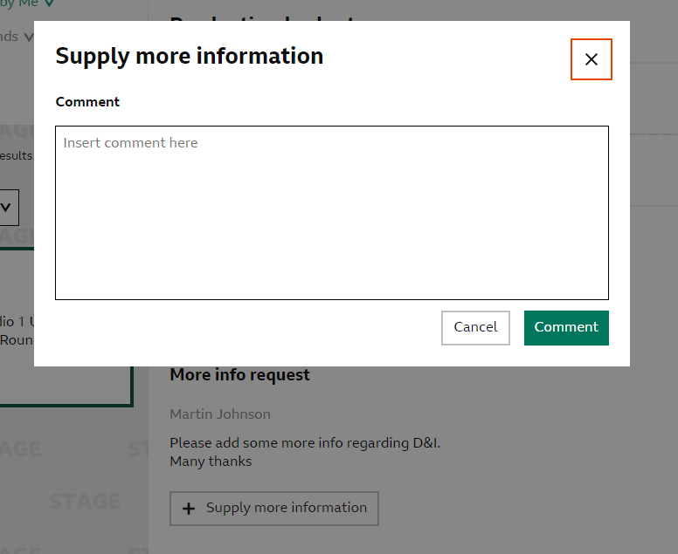
You can then add any information to further support your proposal in response to the ‘More Info request’. Your notes will then be added into the ‘Commissioner feedback and notes’ section and a green banner will appear to highlight that your response has been sent to the commissioner.
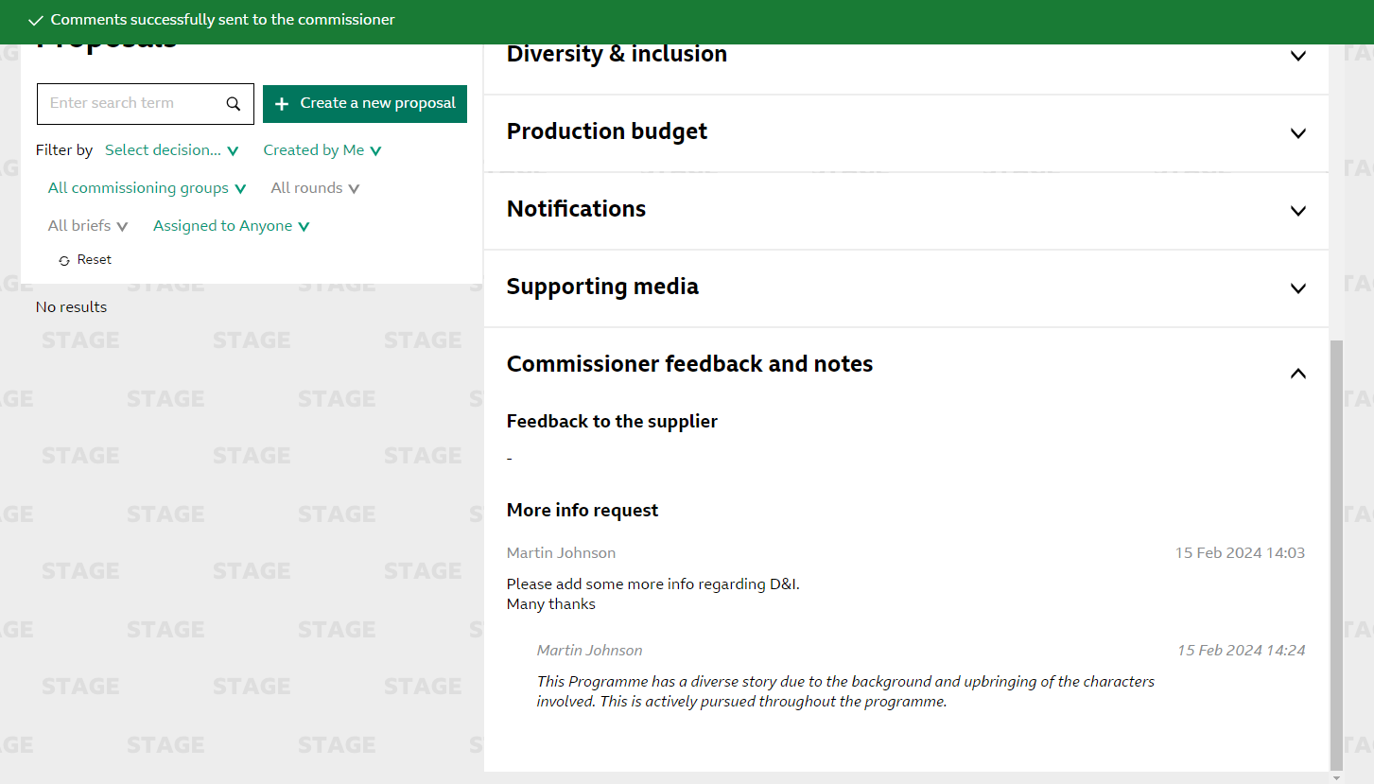
Once submitted, the commissioner will then review the additional information provided and then make a decision on whether to ask for ‘More Info’, ‘Reject’, ‘Conditionally Commission’ or to place the proposal ‘On Hold’.

Two step Proposals – Audio
If your proposal has been successful in the first stage and you have and you are required to then submit a ‘Full Proposal’, you will receive an email notifying you of this status change and your proposal will be sent back to you to re-submit this information.
This proposal will show up on your dashboard under ‘Awaiting Full Proposal’.
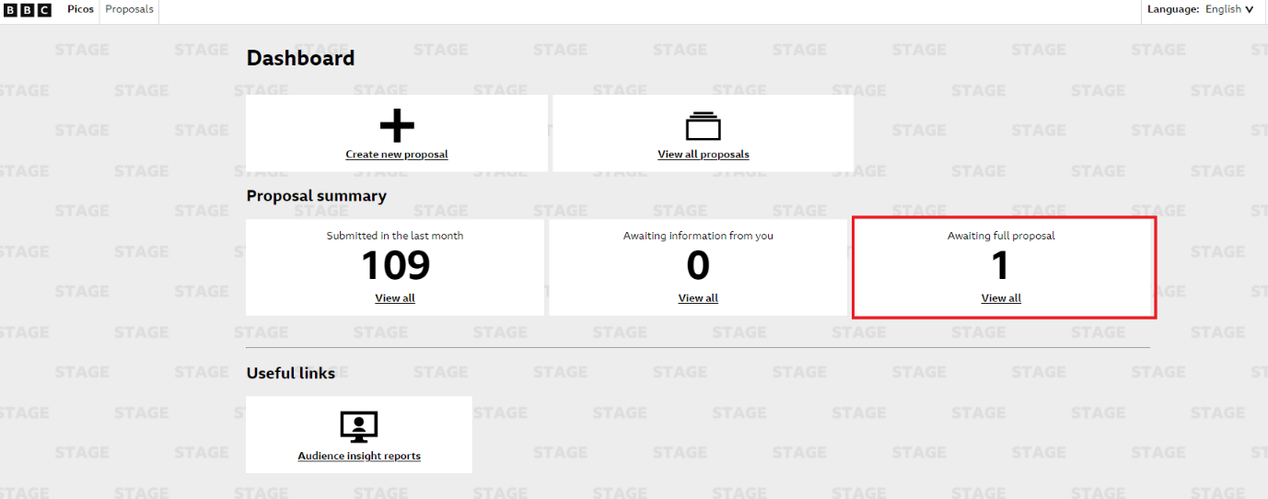
When you click on this link you will be taken to the proposals page where you will see the proposals that requires a ‘Full Proposal’. From here, you can then click into the specific proposal you wish to submit a ‘Full Proposal’ for.
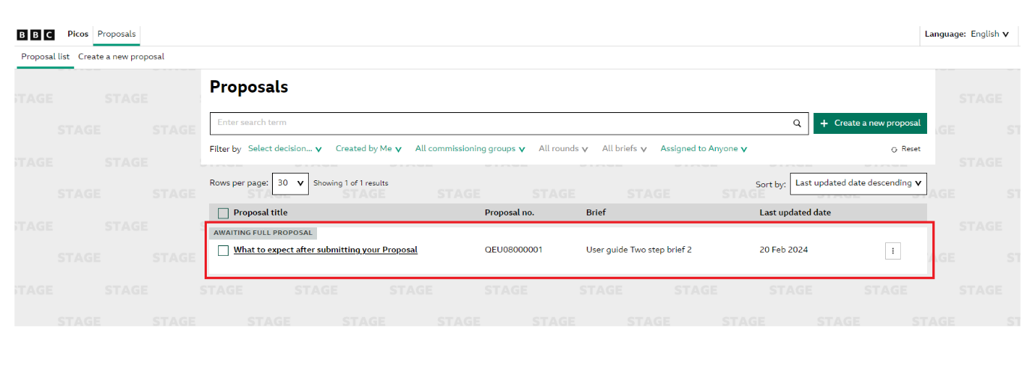
Once you are in the specific proposal, you can scroll to the bottom of your screen where you will see an ‘Edit’ button. If you click on this you will then be able to start re-submitting your proposal to include the ‘Full Proposal’.
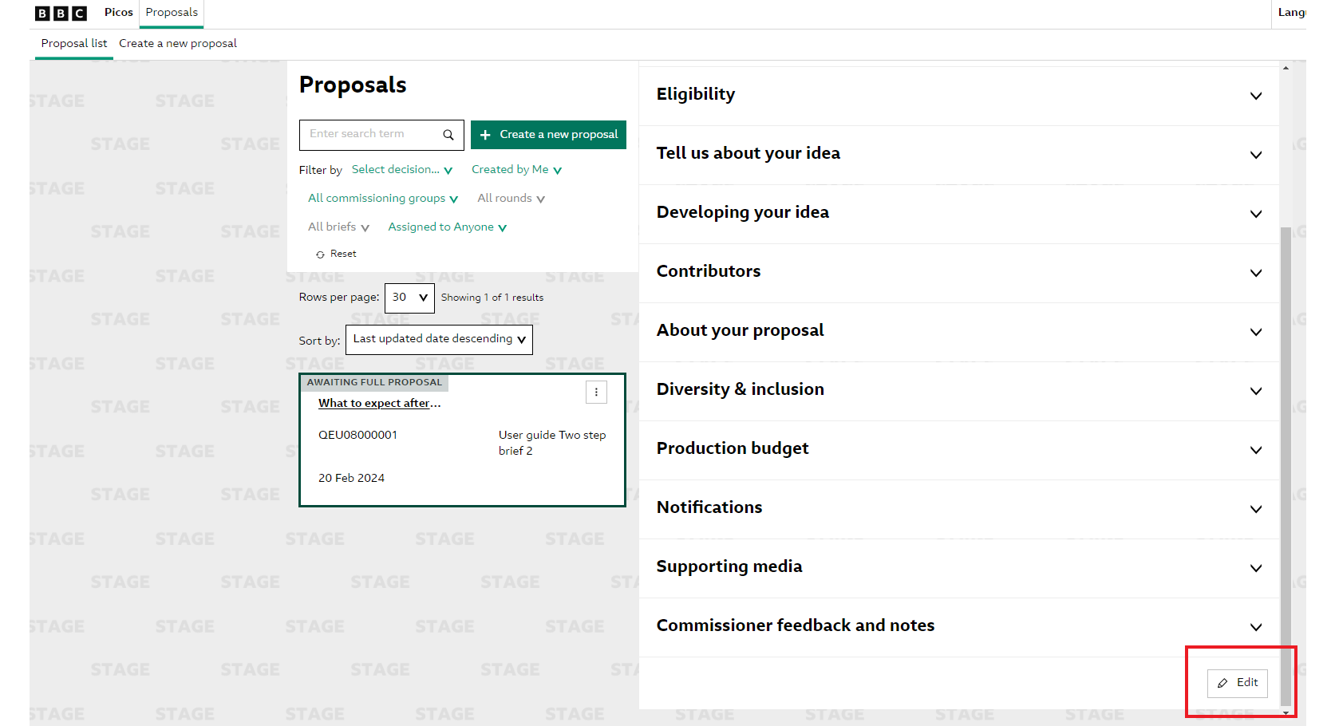
Once you have clicked ‘Edit’ you will see the below pop-up where you can see all relevant information of your proposal and a confirmation it has progressed to the second stage.
Click on ‘Start’ to submit your Proposal.
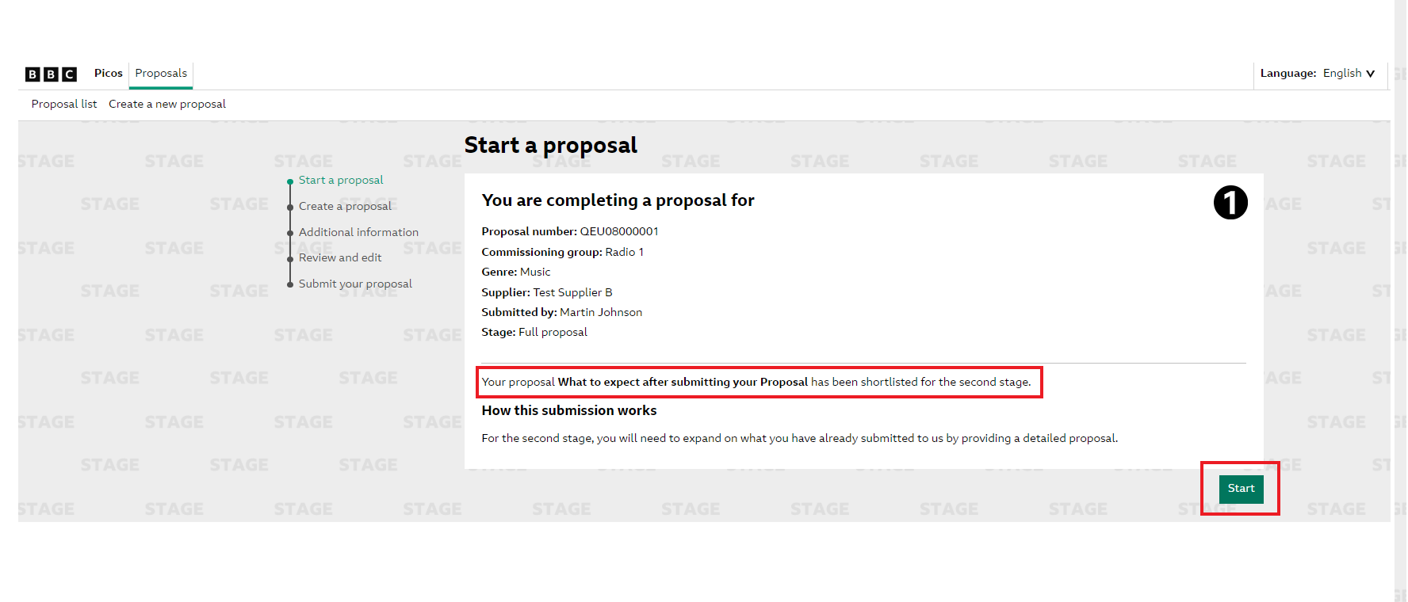
You will now be in your proposal where you can fill in the ‘Developing your idea’ section. This is where you will input your ‘Full Proposal’. Please note that you can also amend other fields at this stage such as ‘Contributors’, ‘About your Proposal and ‘Diversity & Inclusion’.
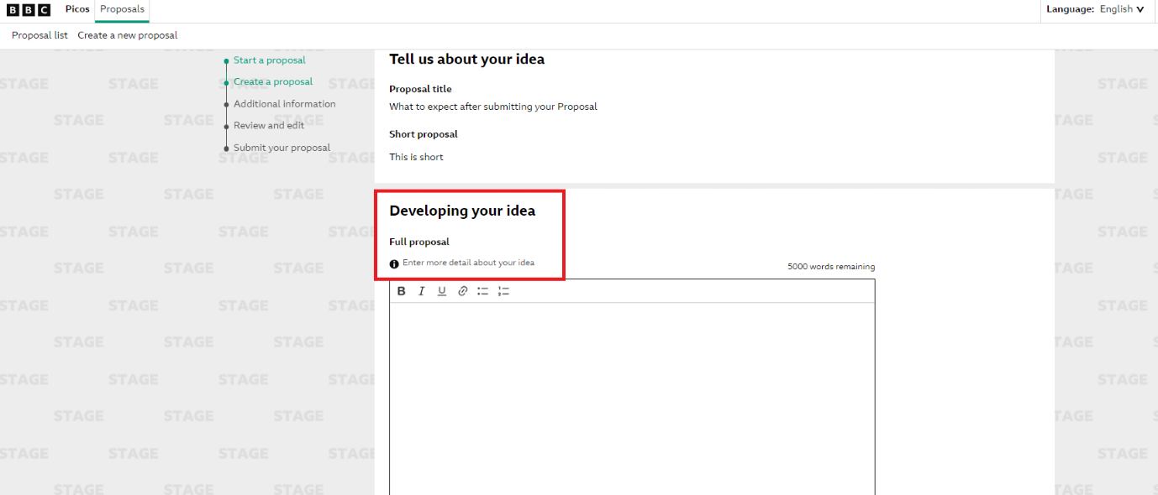
Once you have completed your full proposal and amended any other fields as required, you can then scroll to the bottom of the page and accept the ‘T&Cs’ and click on ‘Additional Information’.
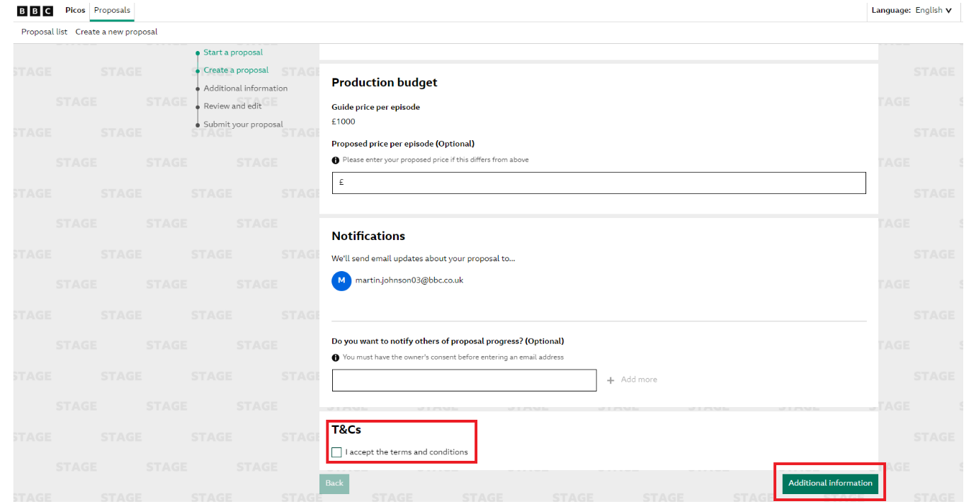
On the ‘Additional Information’ page, you can add any supporting media to your document. Once completed, you can click ‘Review’ which will bring up a summary of your full proposal before you submit.
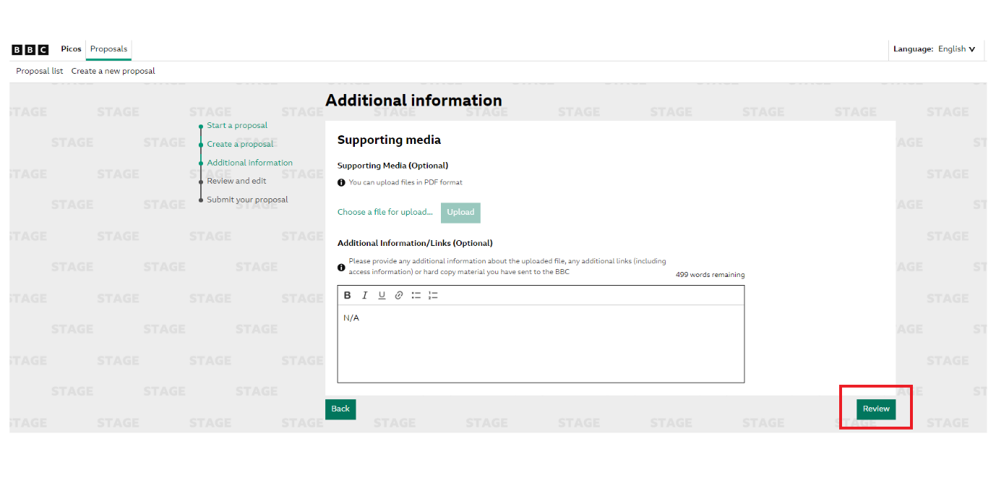
Once you have reviewed your proposal you can scroll to the bottom of the page and click ‘Submit’ this will then bring generate a pop up confirming you have submitted your proposal. You will also be notified by email that your email has been submitted.
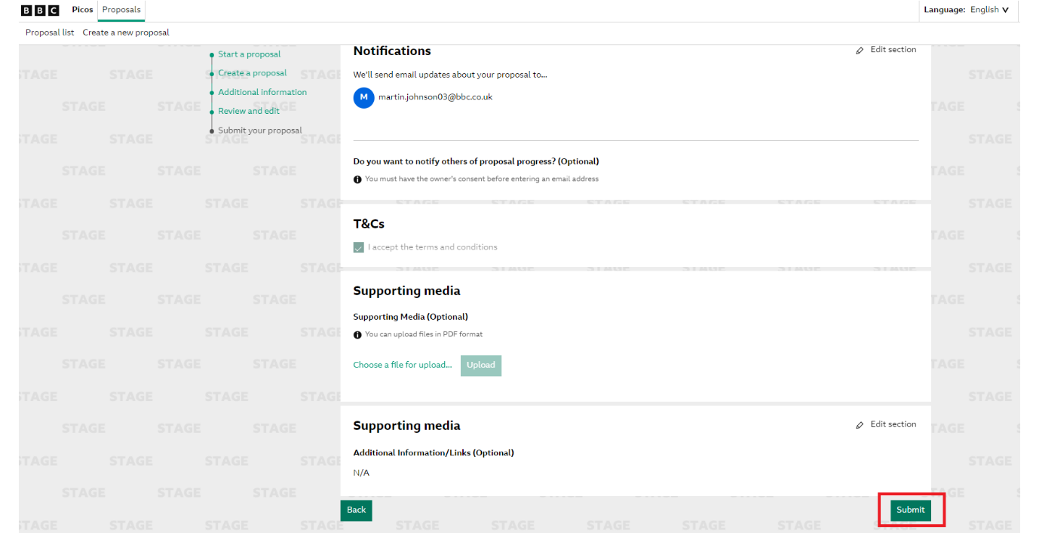

Your programme has been commissioned - Audio
The commissioner will be in contact to confirm that your programme has been commissioned, this can be via the optional email notifications highlighted above.
Once the programme is commissioned, your programme will automatically be migrated into Proteus where the network schedulers will place your programme into the schedule.
You will then be given a Proteus login (if you do not currently have one) to access the system and complete your production paperwork. Please see the Proteus page for more information regarding production paperwork.

Your Programme has been commissioned – TV
Once your programme has been commissioned, you will need to complete the required production paperwork please see our Production and Delivery for more information.

