How to set up a BBC Login Account

When you need a new BBC Login Account
To access PiCoS you need a BBC Login account. If you already have a BBC Login account you will receive an email for confirmation when you have been given access to PiCoS and you don’t need to set a new one up

BBC Login invitation
If you don’t already have a BBC Login account, you will receive an email invite to set one up. If you don’t see the email please check your junk/spam folders. Once you have received the email you must action it within 14 days.
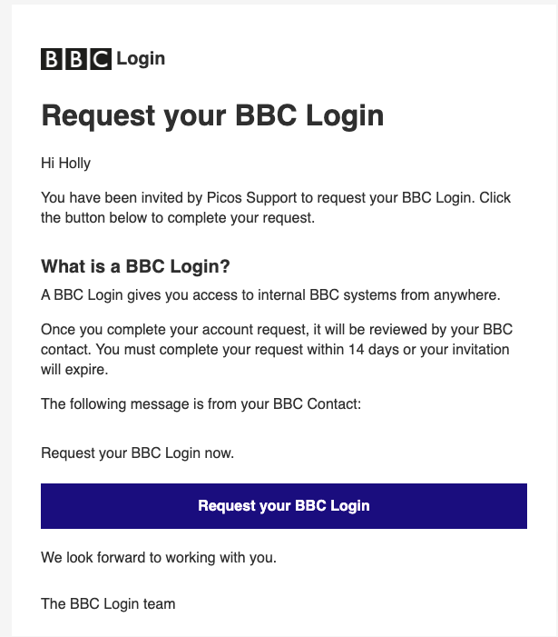

- Click on the Request your BBC Login button in the email. This will take you to the BBC Login request portal.

- Fill in your personal details as requested on the page. Your email address and the BBC contact fields should be automatically populated.
- Create a password.
- Click the Submit request button.

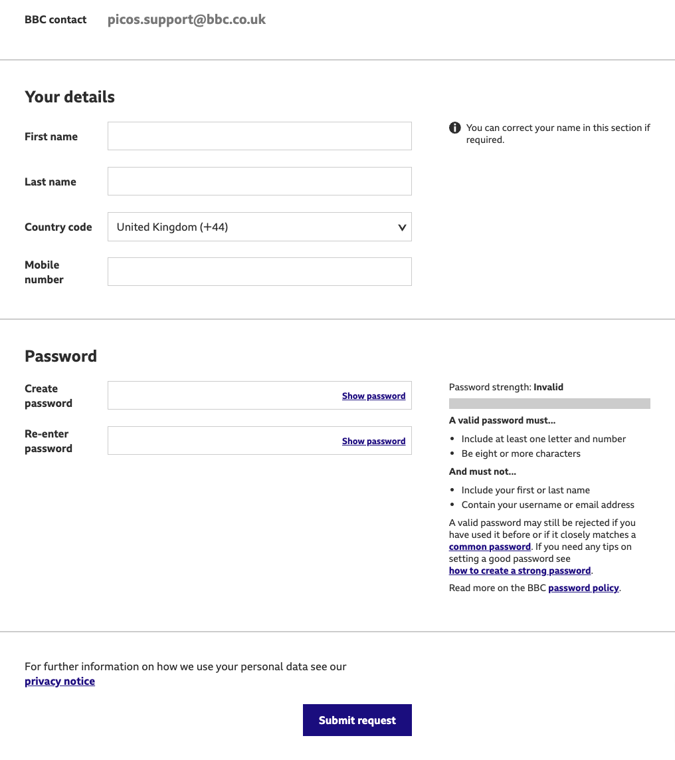

- You should get confirmation on the screen that you have requested a BBC Login.
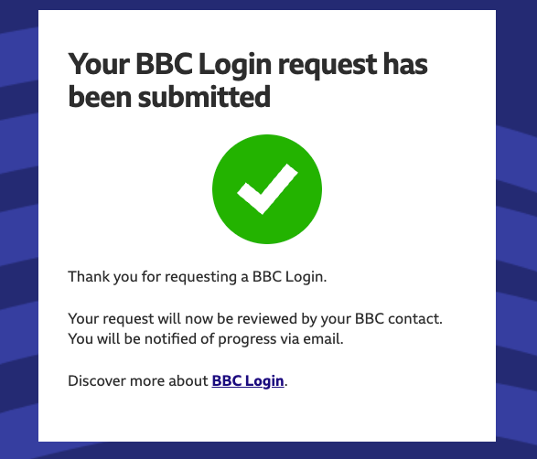

Activating your BBC Login account
1. When your BBC login is approved you will receive an email with an activation link.
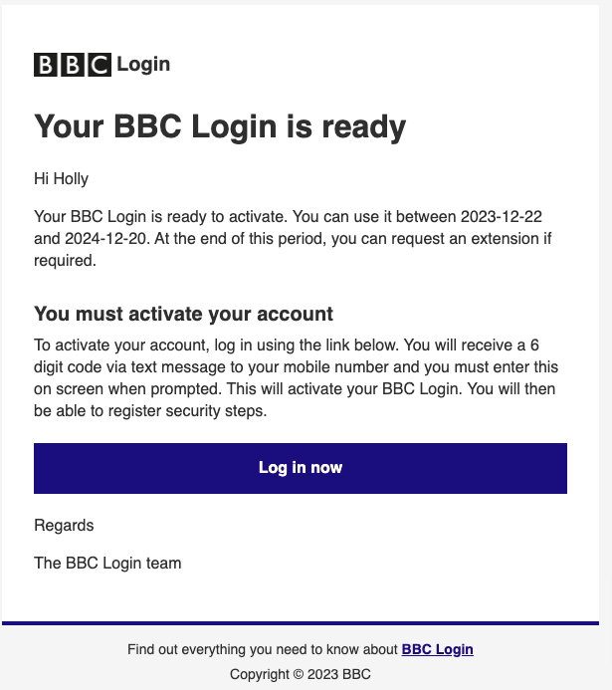
2. Click the Log in now button. Please note this is a link to log in to your BBC Login account and not PiCoS.
3. You will get a prompt to login. Enter the email address you registered with and the password you created earlier.
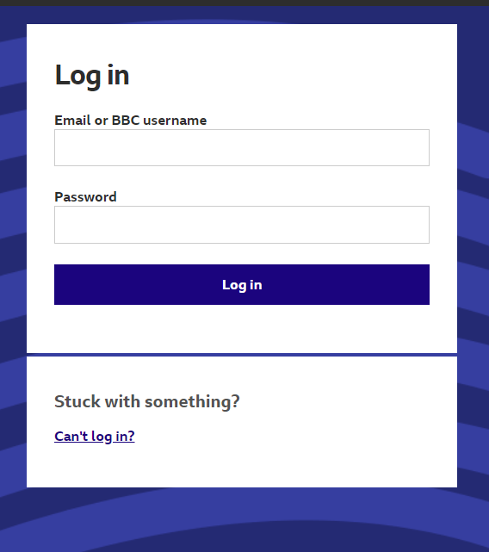

Manage your security steps

- When you have first logged in to BBC Login you should amend your two factor authentication method. You can do this by clicking on the Manage security steps button.

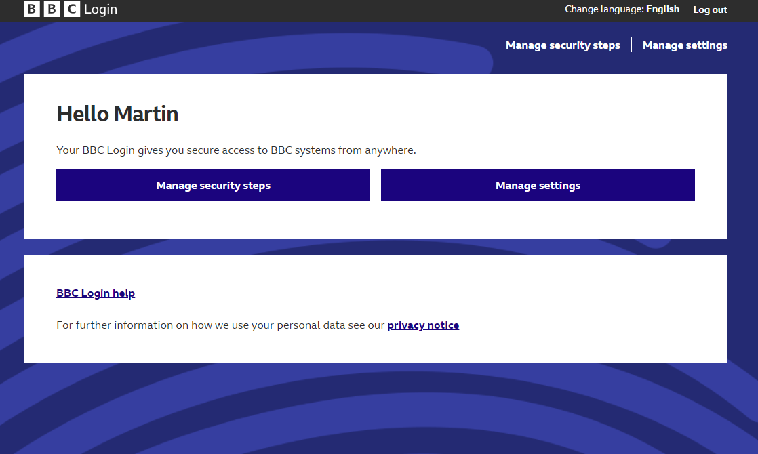

- You will need to enter the code sent to you via SMS.

- You will then be able to register additional security steps. The recommended method is to change your authentication method from SMS to using the ForgeRock app by either clicking the Register for confirm via app or Register for code via app buttons.

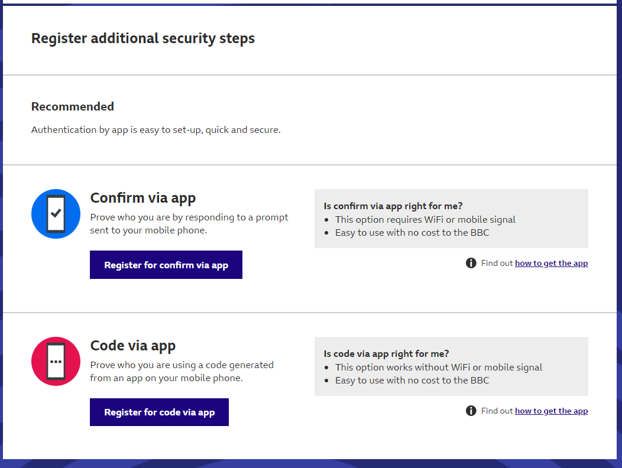

- You have now successfully created your BBC Login account.

Access to PiCoS
Once you have a BBC Login account and the PiCoS site has launched you will be able to access the PiCoS site.
If you have any issues or would like any further assistance, please contact PiCoS.

