Comm Spec Guide for Production Company Users

Contents
Access and Logging in 2
Completing a Comm Spec 2
Accessing Your Specs 2
Filling Out the Spec 3
Submitting to BBC 5
Reviewing a Comm Spec Returned by the BBC 5
Adding Comments 6
Comparing Versions 7
Agreeing a Comm Spec 8
Approval Process 8
Final Agreement 9
Generating a PDF 10
Tips & Reminders 10

Access and Logging in

If you already have access to PiCoS you should also automatically be able to access Comm Spec via a BBC Login EPA account. To access Comm Spec, please login via https://comm-spec.tools.bbc.co.uk/

If you are unable to login to Comm Spec and need access, please raise a request via the support request form or you can email the support team at commspec.support@bbc.co.uk.

Completing a Comm Spec

Accessing Your Specs
- Log into the system to view all comm specs for your production company.
- Use the search bar or the filters to find a specific comm spec.

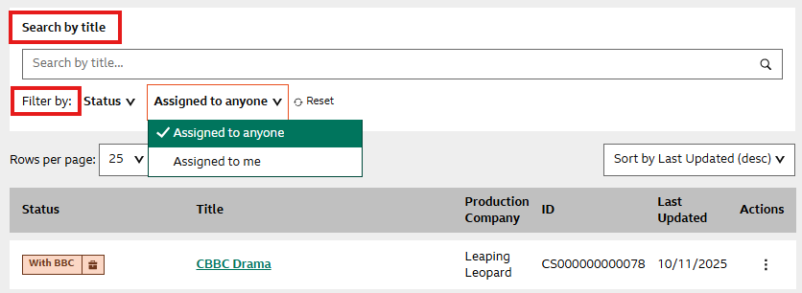

- Comm Specs that are marked as:
  - With BBC – The BBC are reviewing; you cannot edit.
  - With Production – You can edit and complete the spec.

Filling Out the Spec

- Click the spec title to open the Summary Screen.
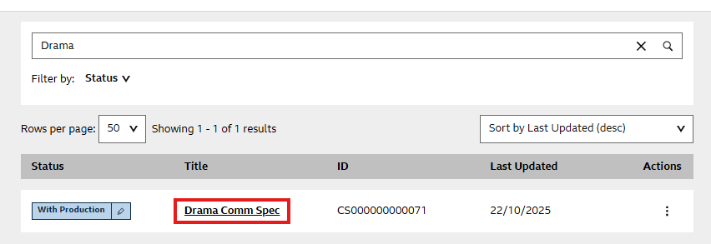

- View section statuses and spec details via the three-dot menu.
- Click a section header to open its form (includes text boxes, radio buttons, tick boxes).

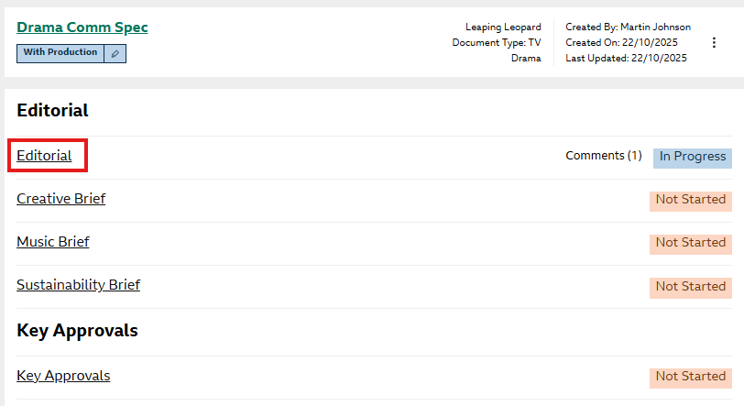

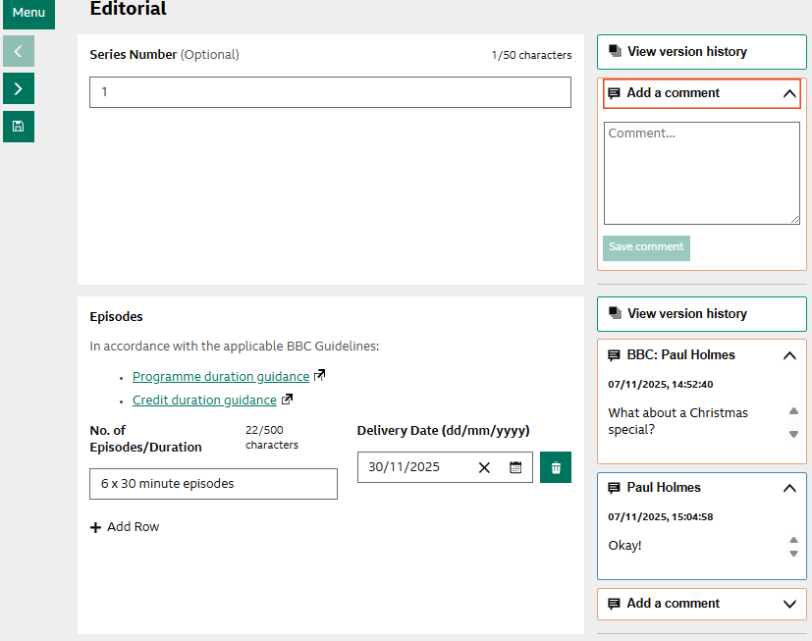

- Save changes before navigating to another section of the Comm Spec. Save via the left-hand side icon, or the save button at the bottom of the page.
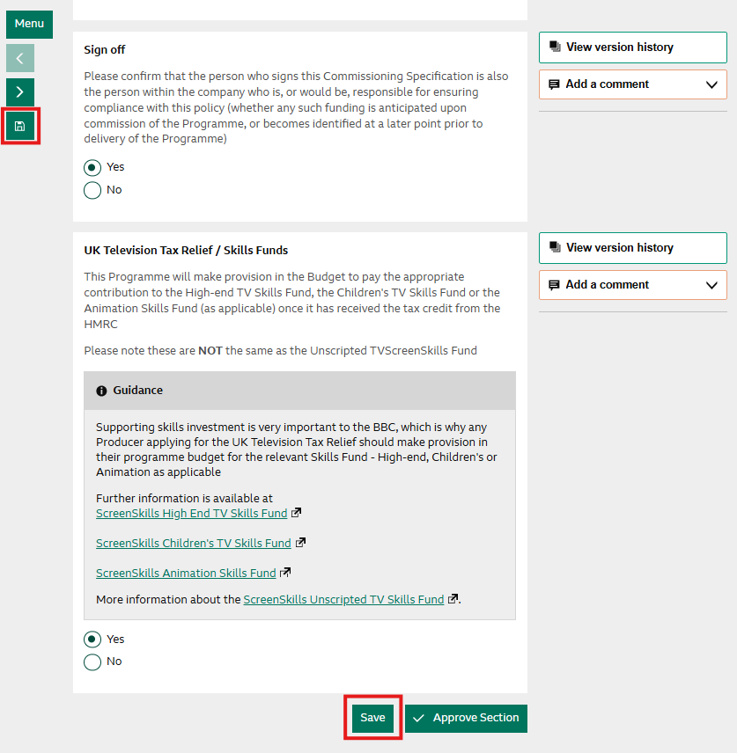

Submitting to BBC

- Return to the Summary Screen.
- At the bottom of the page, click Submit to BBC.

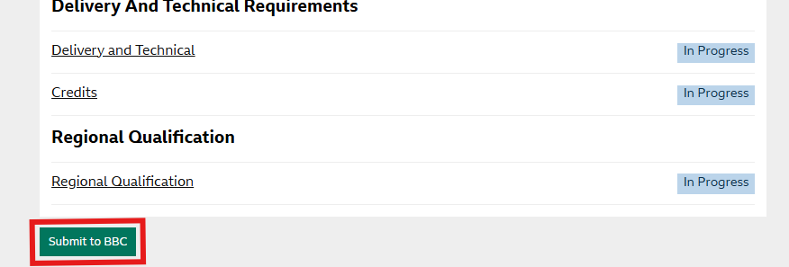

- Status changes to With BBC – editing is locked during review.

Reviewing a Comm Spec Returned by the BBC
- Status changes to With Production.
- Click the spec title to view comments and updates.
- Flags indicate where changes or comments exist, these are also viewable in the side menu when in a specific form.
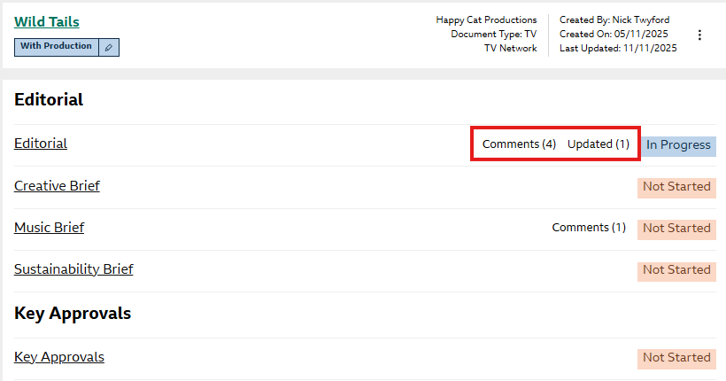

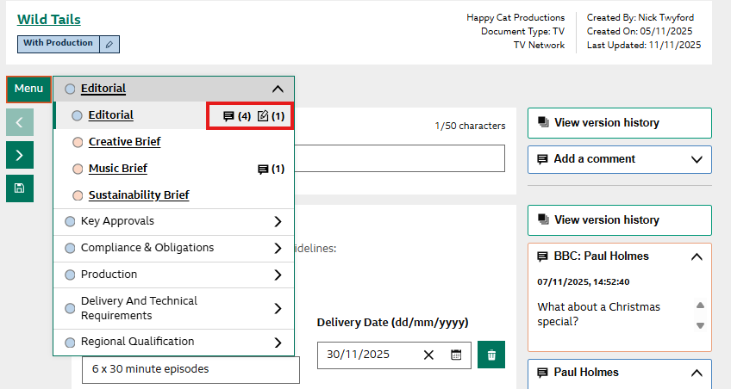

Adding Comments
- Use Add a Comment to respond or flag issues.
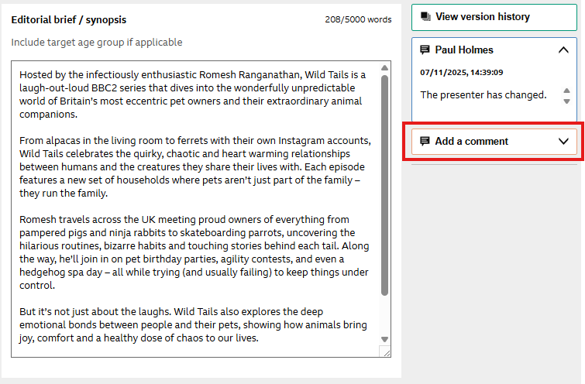

- Comments can be edited, deleted, by selecting the pen or trash can icons within the comment box.

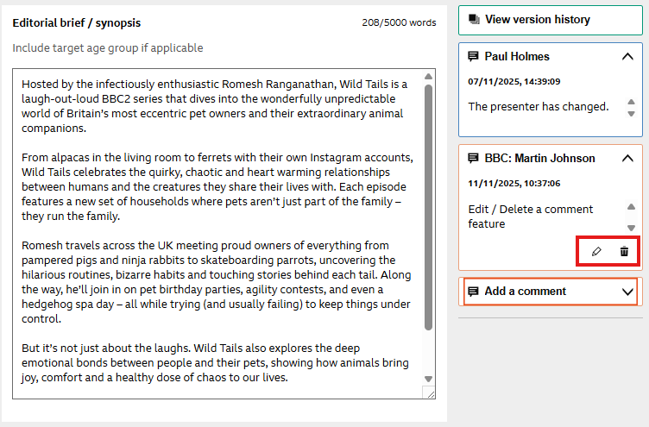

Comparing Versions
- Use Version History in any field to compare changes. Click ‘View Version History’.

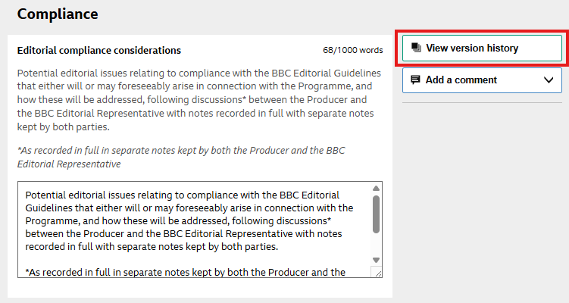

- Select versions from the dropdown to highlight differences. Changes are highlighted in Red and Green

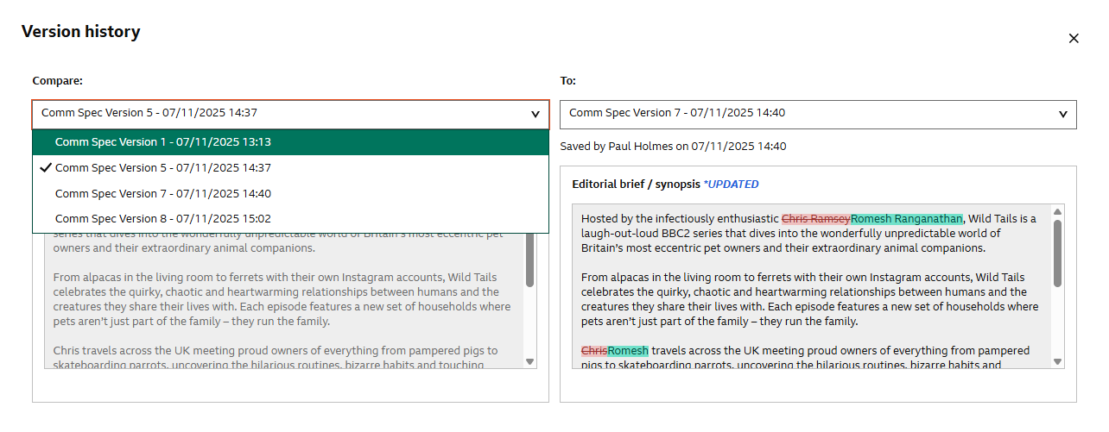

🔸 Note: Only versions with changes are available.

Agreeing a Comm Spec

Approval Process
- BBC approves sections once they have been completed.
- Approved sections become locked.
- The status of the form updates to Approved in Summary Screen.

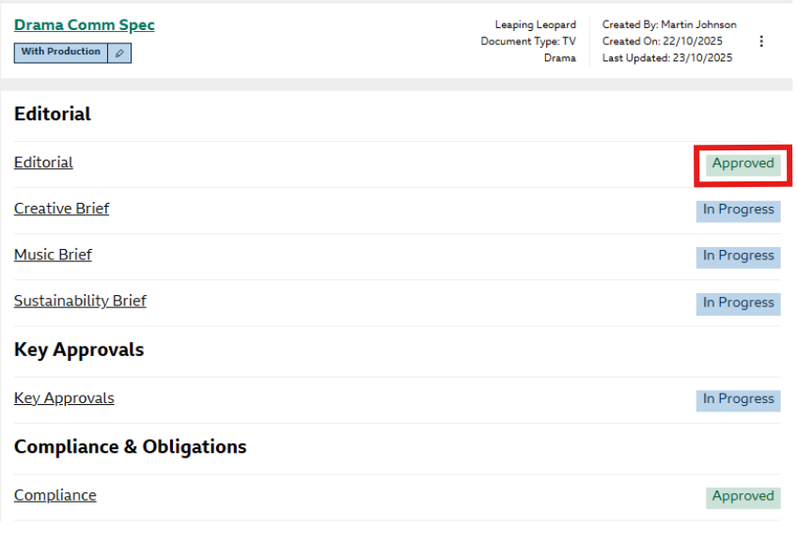
🔸 Note: Forms can be unlocked if needed but this can only be actioned by the BBC. Please ask your BBC contact to unlock them if needed so you can make the necessary amendments.

Final Agreement
- Once all sections are approved and the BBC have signed off the comm spec the status changes to With Production – Ready to Sign.
- Click three-dot menu → Agree and sign.

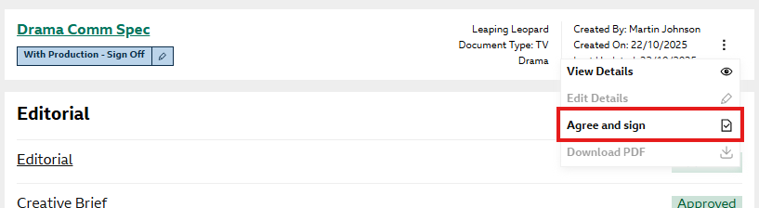

- Tick confirm, then confirm.

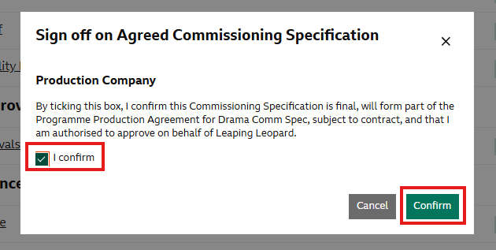

- Status changes to Agreed – spec is locked.

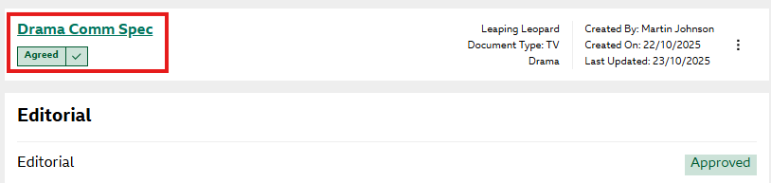

Generating a PDF
- After agreement, the spec is locked.
- Use the three dots menu → Create PDF.

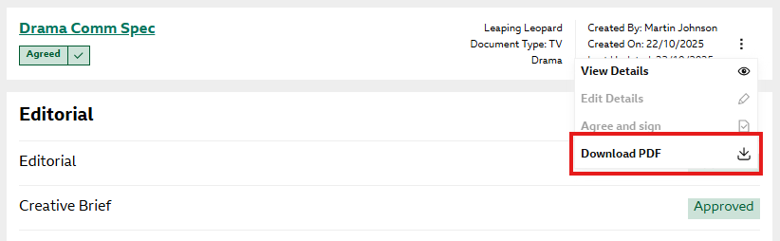

- This PDF will now open in a new window. This PDF is used by BBC to create your contract.

Tips & Reminders
- Always save before switching sections.
- Use comments to communicate with BBC reviewers.
- Check version history on forms to monitor and view track changes.
- Only submit when you're ready – editing locks once submitted.

