
NI4 FACT SHEET
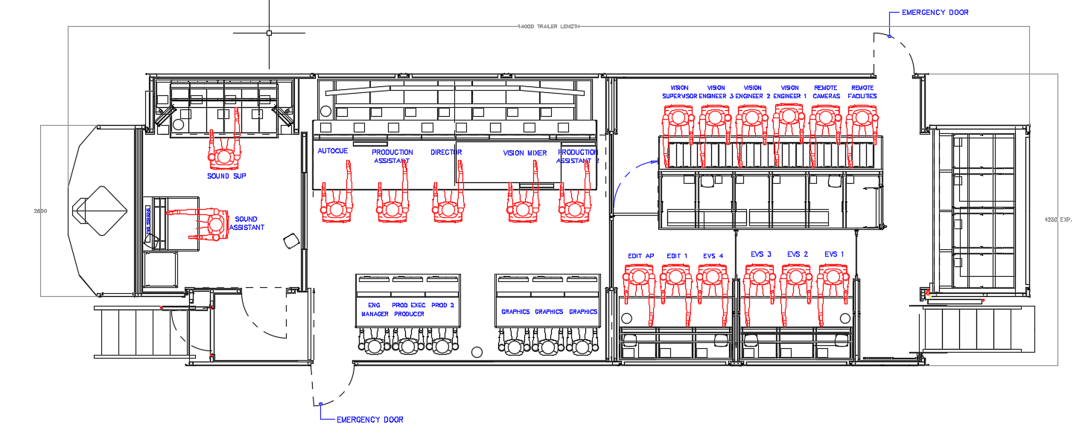

Dimensions (metres). | Length | Width | Height
Stored | 14 | 2.5 | 4
Operational | 14 | 4.25 | 4
Weight | 33 T

Power
1 x 125 Amp 3 Phase.
UPS Back system for 20 minutes, Media protection only.

VISION SYSTEM ST 2110-20 Video over IP system with -07 Redundancy.
Vision Mixer
Sony MLS-X1 with 96 inputs and 64 Outputs at HD.
Vision System
22 x Imagine Communications, Selenio Network Processors IP Multiviewers.
14 x Imagine Communications, Selenio Network Processors IP HD Gateways (Internal) with 76 HD Inputs, 176 HD outputs each with 16 Channels embedded audio.
Cameras
System Cameras 13 x Sony HDC-3500 HD/3G, 4K and HFR by license, wired for 16.
Slomo Cameras 1 x Sony HDC-3500 HFR (x2) (x3) (x4) HD/3G, 4K by license.
Box Camera 1 x Sony P50 HD/3G, 4K and HFR by license.
PTZ Cameras 2 x BRC-800 Remote PTZ HD/3G; Wired for 4.
Radio Cameras 2 x Videosys Systems; Wired for 4.
Optics
Canon studio lenses.
Canon EFP lenses.
On Board recording
2 x EVS XT-VIA 12 Channel with 277 Hours capacity each at DNxHD120 bit rate, wired for 4 units.
EVS -IP Director system with removable storage, wired for 2.
2 x Atomos Shogun Studio2, 8 Channel recorders at HD.
External
Wired for 14 dual redundant stage boxes on TAC4 optical fibre.
6 x Imagine Communications Selenio Network Processors IP HD Gateways on remote video stage boxes with 56 HD Inputs 24 HD outputs.
4 x Calrec Audio Ltd, stage boxes Audio Large size with 192 Inputs x 64 Outputs.
2 x Calrec Audio Ltd, stage boxes Audio Mid-size with 48 Inputs x 24 Outputs.

Audio System ST 2110-30 Audio over IP system with -07 redundancy.
Audio Mixer
Calrec Audio Ltd, Artemis digital audio console, 48 fader digital Sound desk.
2 x Calrec Audio Ltd, Impulse IP Core with Bluefin3, 384 Channel with 4096 x 4096 Routes on dual redundant cores.

Communications System
Riedel 1024 IP Communication system with 148 x 148 ports and Riedel 1200 series smart panels.
2 x Riedel Commentators Panels.
Riedel Bolero Wireless talkback with 13 Handsets.
2 x Motorola UHF Talkback with 12 handsets.
2 x Systembase Multiformat Codecs 4 channel (TBU's).
1 x Comrex 5 channel stereo IP Codec.
Audio Processing
1 x Waves Sound Grid Audio Processor 32 Channel.

Audio Record and Playback
1 x JoeCo audio recorder 64 channel Dante audio recorder.
1 x Reaper 128 channel, Dante and Madi, PC based audio recorder.
1 x SpotOn 16 channels PC based audio playback and record.

Graphics
2 x VizRt IP Graphics engine, wired for 4 .

Production Areas Seating
5 x Production front desk.
6 x Production rear desks.
3 x EVS.
3 x EDIT Area.

Production Monitoring
Vision 8 x OLED monitors with fully configurable Multiviewers. Up to 128 PIPs. With UMD and Red / Green Tally.
Sound 5.1 Audio monitoring within production gallery with calibration system.

Network
Arista Spine / Leaf IP system with 7280CR3-96 series: 96 port QSFP100 - 9.6 Tbps wire speed performance with 16GB buffer - Supports 96 x 100G QSFP or up to 192 x 50G".
@3840 x 3840 Routes at 1080 / 50i a max number of streams 7680 in or out.
@1920 x1920 Routes at 1080 / 50p a max number of streams 3840 in or out.
1 x PepWave, Bonded 3/4/5G Mobile data connection.

